**Nov 2017 HL P1**

**Section A**

1. Identify **two** essential features of a computer language. [2]
2. In the context of a networked world, state the role of
3. a client. [1]
4. a server. [1]
5. Identify **one** method of inputting data that can improve the accessibility of a computer

system for some users. [1]

1. Copy and complete the following truth table. [3]

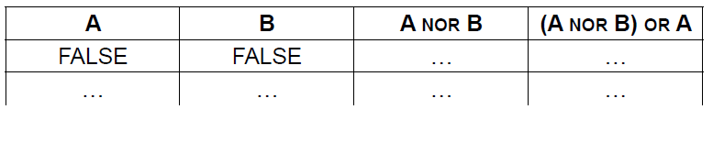

1. Construct a logic diagram for the Boolean expression

NOT A OR B AND C. [3]

1. Consider the following recursive method, where N is a positive integer

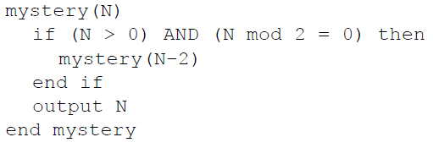

1. Determine the output produced by the method call mystery(5). [1]
2. Determine the output produced by the method call mystery(4). [3]
3. Construct an iterative algorithm for the method mystery(), which uses a single

while loop instead of recursion. [4]

1. The machine instruction cycle is the process by which a program instruction is fetched,

decoded, executed and the results are stored.

1. State where all instructions and data are stored. [1]
2. Outline the role of the data bus and address bus in this process. [2]
3. Define the term bit. [1]
4. Outline what is meant by beta testing. [2]

**Section B**

1. An application package used in an office includes a word processor.
2. Describe how a spellchecker checks whether a word in a text file is correctly spelt

or not. [2]

The office manager decides to buy and install new software and hardware.

1. Outline **one** problem that may arise from the installation of new hardware and software  
   in the office. [2]

The changeover to the new system can be achieved by either direct changeover or   
phased conversion.

1. Compare direct changeover and phased conversion. [4]

The new software allows basic text summaries and analysis to help check text files,  
 including functions such as calculating word frequency.

1. Identify **one** way of testing this software. [1]

One of the methods in this software is findFirst(CH, CHARARRAY) which accepts a character, CH, and a one-   
 dimensional array of characters, CHARARRAY, and returns the position of the first occurrence of character CH in   
 CHARARRAY. It returns −1 if CH does not appear in the array CHARARRAY.

For example, consider the character array MESSAGE, which is of length 19.



For this array:

* The character at position 8 in the sentence is “U” and hence MESSAGE[8] = "U".
* The character at position 18 in the sentence is “.” and hence MESSAGE[18] = ".".
* The method findFirst('A', MESSAGE) returns 0.
* The method findFirst('S', MESSAGE) returns 9.
* The method findFirst('Z', MESSAGE) returns −1.

1. Construct an efficient algorithm for the method findFirst(). You should use the function len(),   
   which returns the number of characters in an array (for example, len(MESSAGE) returns 19). [6]
2. A wireless local area network (WLAN) is used to extend access to a school’s wired

local area network.

1. Identify **one** hardware component of the WLAN, other than computers. [1]

The advantages of this WLAN are user-mobility and economical access points.

1. Outline **two** disadvantages of this WLAN. [4]

1. Identify **three** ways in which the network administrator can reduce the risk of   
   unauthorized access to confidential data. [3]

The concept of packet data transmission is used within this network. Figure 1 shows the   
 simplified structure of a data packet.

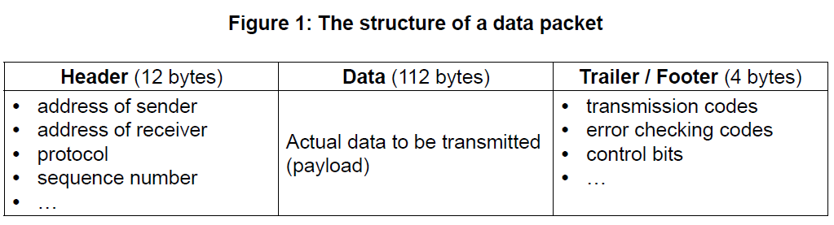

1. Define the term protocol. [1]
2. With reference to **Figure 1**, explain how data is transferred by packet switching. [6]
3. A biotechnology company owns a resource centre which collects and classifies organisms

for use in research.

Only authorized employees are allowed access to some laboratories in the resource centre.

These laboratories are protected by locked doors. Each door is controlled by a separate microprocessor. A digital camera is used to scan the iris of an employee who wishes to

enter the lab. If the employee is authorized the doors are unlocked.

1. Identify **two** benefits of using a digital camera as an input device in this control system. [2]
2. Outline the use of a microprocessor in this control system. [2]
3. Outline the function of an output transducer. [2]

The company is planning to use a centralized computer system to secure the resource  
 centre’s building.

1. Compare a centrally controlled system with the system described above. [4]

The operating system has an important role in this system.

1. Identify **two** functions of the operating system. [2]

Polling and interrupt are two operating system management techniques.

1. Suggest with reasons which of these two techniques is the most appropriate for   
   this centrally controlled system. [3]
2. (a) Describe the features of a dynamic data structure. [2]

Consider the following doubly linked list which holds the names of flowers in  
 alphabetical order.



(b) Explain how “Primrose” could be inserted into this doubly linked list. You should   
 draw a labelled diagram in your answer. [6]

Consider the two stacks: FLOWERS and FRUITS.

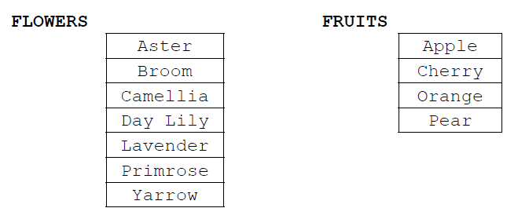

1. 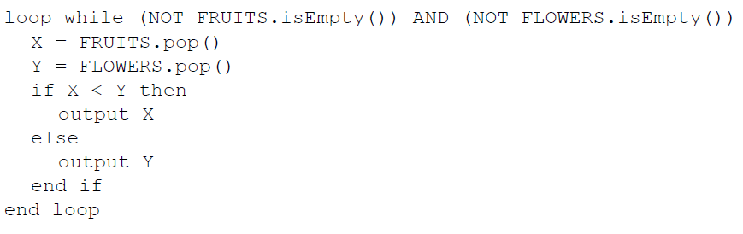Show the output produced by the following algorithm. [4]

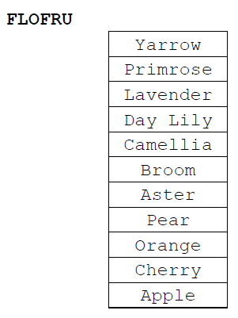A third stack, FLOFRU, is needed. It should contain all the data from FLOWERS and FRUITS and will store it as shown below

1. Describe how the FLOFRU stack could be created. [3]
2. Consider the following two-dimensional array, MAT, with dimensions 6 × 6.

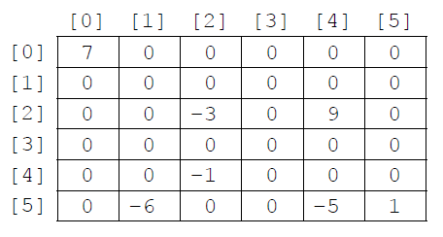

The value −1 is stored in MAT at position [4][2]. The position [4][2] means row 4  
 and column 2.

1. State the total number of elements stored in MAT. [1]
2. State the number of non-zero elements in MAT. [1]

A two-dimensional array in which most of the elements are zero is called a **sparse matrix**. A sparse matrix can be compressed by storing only non-zero elements using three one‑dimensional arrays.

The **first array**, VALUES, stores all non-zero elements taken from the sparse matrix in row‑major order (left-to-right then top-to-bottom order).

The length of the array VALUES is equal to the number of non-zero elements in the sparse matrix. For the sparse matrix above, MAT, the array VALUES is:

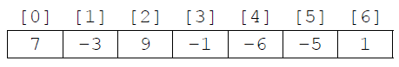

The **second array** is ROWC. ROWC[i] stores the number of non-zero elements, from row 0 to row i of the sparse matrix, **inclusive**.

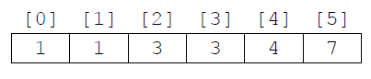The length of ROWC is equal to the number of rows in the sparse matrix. For MAT the array ROWC is:

For example, ROWC[2] stores 3 because in MAT there are three non-zero elements from row 0 to row 2, inclusive.

The **third array**, COL, stores the column index for each non-zero element in the sparse matrix. COL[i] stores   
the sparse matrix column index for the non-zero element stored in VALUES[i]. For MAT the array COL is:

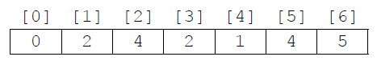

1. Construct an algorithm that compresses a 6 × 6 two-dimensional array, such as MAT,   
   into the three one-dimensional arrays described on page 8. You may assume that the   
   6 × 6 array is inputted and all three one-dimensional arrays are initialized. [6]

Consider the following three arrays. They hold the compressed contents of a 7 × 7 sparse   
 matrix, BIGMAT.

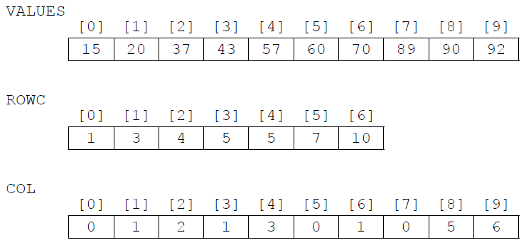

1. For a given column, C, in BIGMAT, outline how it could be determined that this column contains  
    no non-zero elements. [2]

1. State how many rows in BIGMAT contain only zeros. [1]

1. (i) State the index in VALUES of the first non-zero element in row 5 of BIGMAT. [1]  
     
   (ii) For a given row, R, in BIGMAT, determine the range of indexes in VALUES where  
    non-zero elements in row R of BIGMAT are placed. You may assume that there  
    is at least one non-zero element in row R. [3]